#

# **DOOR HANDLE SANITIZER**

A MINI PROJECT

REPORT

*Submitted by*

**NAME OF THE STUDENTS**

S SHAWIN KRISHNA – 1NH18EE740

SMD ADIL – 1NH18EE745

PAVAN KUMAR- 1NH18EE744

*In partial fulfilment for the award of the degree of*

BACHELOR OF ENGINEERING

IN

ELECTRICAL AND ELECTRONICS ENGINEERING



**Bonafide Certificate**

This is to Bonafide that the mini project report entitled “**Door Handle Sanitizer**” submitted by **S Shawin Krishna, SMD Adil, Pavan Kumar**, Department of Electrical and Electronics Engineering, New Horizon College of Engineering, Bangalore in partial fulfilment for the award of the degreeof Bachelor of Engineering , is a record of bonafide work carried out by him/her under my supervision, as per the NHCE code of academic and research ethics.

The contents of this report have not been submitted and will not be submitted either in part or in full, for the award of any other degree or diploma in this institute or any other institute or university. The project report fulfils the requirements and regulations of the institution and in my opinion meets the necessary standards for submission.

|  |  |
| --- | --- |
| Guide Name  **Mr.Mohan Das** | **Dr. Mahesh.M**  **HoD** |



**Acknowledgement**

With immense pleasure and deep sense of gratitude, I wish to express my sincere thanks to my supervisor **Mr.MOHAN DAS**, Professor, Department of Electrical and Electronics Engineering, New Horizon College of Engineering, without her/his motivation and continuous encouragement, this mini project would not have been successfully completed.

I am grateful to the Chairman of New Horizon Educational Institution, **Dr. Mohan Manghnani** for motivating me to carry out research in the NHCE and for providing me with infrastructural facilities and many other resources needed for my project work.

I express my sincere thanks to **Dr.Mahesh.M** HoD, Department of Electrical and Electronics Engineering, New Horizon College of Engineering for his kind words of support and encouragement.

I wish to extend my profound sense of gratitude to my parents for all the sacrifices they made during my project and providing me with moral support and encouragement whenever required.

Date:

Place: BANGALORE

YOUR NAME(s)

S.SHAWIN KRISHNA

SMD.ADIL

PAVAN KUMAR

**Abstract:**

In these difficult times it's an extreme got to save ourselves from various harmful bacteria and viruses which are a threat to mankind. thanks to this COVID-19 situation people became more conscious of the importance of cleanliness & hygiene and have started giving importance to non-public and environmental sanitation. Cleaning and disinfection helps to scale back the incidences of healthcare associated infections.

In the coming years there'll be a serious need for various methods of eliminating biological organisms that are harmful to health and that we will need different methods of sanitation to try to to so. In our daily lives we encounter various contact surfaces like door knobs which have great possibility of containing harmful bacteria. Thus we've come up with a replacement door knob sanitizing device which may be installed in various public places which treats the door knobs/handles to form it bacteria free.

**DOOR HANDLE SANITIZER**

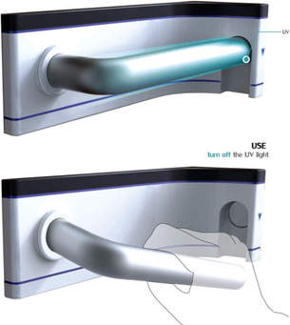

**Index**

1. Introduction
2. Theory
3. Components
4. Components Description
5. Table
6. Working of Project
7. Circuit Diagram
8. Hardware picture
9. Conclusion
10. Applications
11. Appendices
12. Bibliography

**Introduction**

Environmental cleaning and disinfection are important factors of a comprehensive strategy so as to regulate healthcare-associated infections, especially in crowded places where there's endless contact with door knobs/handles. However, studies evaluating the effectiveness of improved cleaning interventions have shown that approximately 5–30% of surfaces remain contaminated, thanks to the shortage of existing disinfectant methods. There has been tons of interest within the development of effective and more comprehensive environmental disinfection strategies.

Huge amounts bacteria are deposited on the door handle publicly toilets and washrooms. albeit you'll take the time to thoroughly wash your hands before leaving, you're quite likely getting to need to touch the handle another time . Although you're clean, the one that touched it before you'll have just blown their nose.

Washing hands regularly is just not enough to prevent this type of germ breeding on door handles from occurring. Harmful bacteria or viruses will still get on your hands and possibly causing infections to you et al. .

consistent with this invention there's provided a door handle device that's positioned on ward doors or lavatory doors that when operated automatically sprays an alcohol based or equivalent disinfectant on the hand and on the door handle. This action will tend to form the operator rub their hands together to assist evaporation of the disinfectant thereby helping personal and public hygiene helping to scale back sickness and disease among patients and therefore the general public when entering a hospital wards or leaving lavatories.

The action of operating the door handle creates a pivotal movement of the handle at one end and therefore the other end having a leg, which operates directly, or indirectly a replaceable canister of disinfectant. The device is capable of working in any position throughout an angle of 300 and sixty degrees and may easily replace any existing door handles.

we've used similar technology in building our device which can disinfect the door knobs/handles & effectively stop the spread of bacteria through door knobs/handles. This device will help us to scale back the spread of health-care associated infections to an honest extent.

**Components:**

|  |  |
| --- | --- |
| **NAMES** | **QUANTITY** |
| Servo motor | 1 |
| Cell holder | 1 |
| Arduino | 1 |
| Jumper wires | 1 |
| Battery | (2-4)5V |

**Components Description:**

* **Servo Motor**

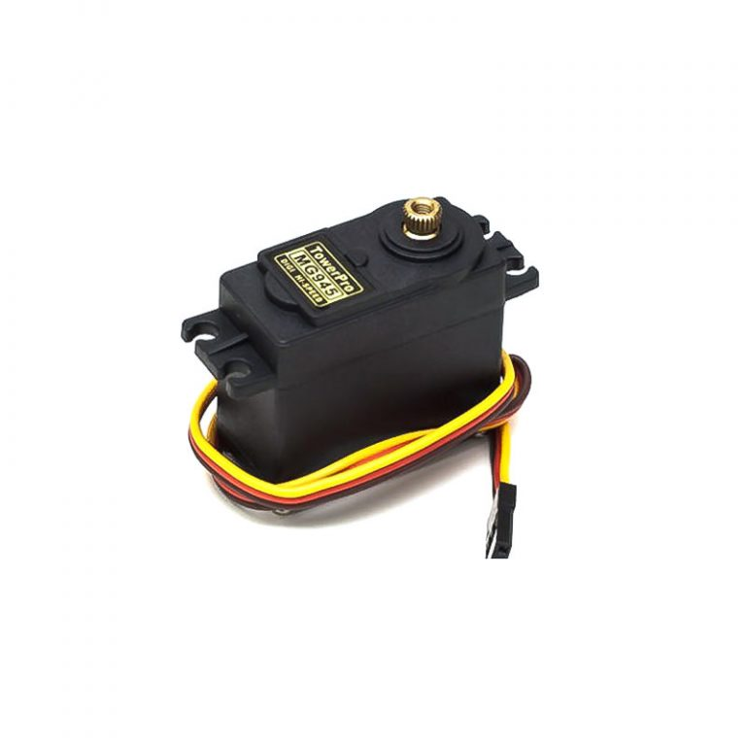

A servomotor may be a positioner or linear actuator that permits for precise control of angular or linear position, velocity and acceleration. It consists of an appropriate motor coupled to a sensor for position feedback. It also requires a comparatively sophisticated controller, often a fanatical module designed specifically to be used with servomotors.

Servomotors aren't a selected class of motor, although the term servomotor is usually wont to ask a motor suitable to be used during a closed-loop system . A servomotor may be a closed-loop servomechanism that uses position feedback to regulate its motion and final position. The input to its control may be a signal (either analogue or digital) representing the position commanded for the output shaft.

The motor is paired with some sort of position encoder to supply position and speed feedback. within the simplest case, only the position is measured. The measured position of the output is compared to the command position, the external input to the controller. If the output position differs from that required, a mistake signal is generated which then causes the motor to rotate in either direction, as required to bring the output shaft to the acceptable position. because the positions approach, the error signal reduces to zero and therefore the motor stops.

The very simplest servomotors use position-only sensing via a potentiometer and bang-bang control of their motor; the motor always rotates at full speed (or is stopped). this sort of servomotor isn't widely utilized in industrial motion control, but it forms the idea of the straightforward and cheap servos used for radio-controlled models.

More sophisticated servomotors use optical rotary encoders to live the speed of the output shaft and a variable-speed drive to regulate the motor speed. Both of those enhancements, usually together with a PID control algorithm, allow the servomotor to be delivered to its commanded position more quickly and more precisely, with less overshooting.

Servomotors are generally used as a high-performance alternative to the stepper motor. Stepper motors have some inherent ability to regulate position, as they need built-in output steps. This often allows them to be used as an open-loop position control, with none feedback encoder, as their drive signal specifies the amount of steps of movement to rotate, except for this the controller must 'know' the position of the stepper motor on power up. Therefore, on first power up, the controller will need to activate the stepper motor and switch it to a known position, e.g. until it activates an end limit switch. this will be observed when switching on an inkjet printer; the controller will move the ink jet carrier to the acute left and right to determine the top positions. A servomotor will immediately address whatever angle the controller instructs it to, no matter the initial position at power up.

The lack of feedback of a stepper motor limits its performance, because the stepper motor can only drive a load that's well within its capacity, otherwise missed steps under load may cause positioning errors and therefore the system may need to be restarted or recalibrated. The encoder and controller of a servomotor are a further cost, but they optimise the performance of the general system (for all of speed, power and accuracy) relative to the capacity of the essential motor. With larger systems, where a strong motor represents an increasing proportion of the system cost, servomotors have the advantage.

There has been increasing popularity in closed-loop system stepper motors in recent years. They act like servomotors but have some differences in their software control to urge smooth motion. the most advantage of a closed-loop system stepper motor is its relatively low cost. there's also no got to tune the PID controller on a closed-loop stepper system.

* **Cell holder:**

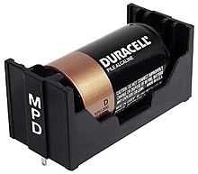

A battery holder is one or more compartments or chambers for holding A battery . For dry cells, the holder must also make contact with the battery terminals. For wet cells, cables are often connected to the battery terminals, as is found in automobiles or emergency lighting equipment.

A battery holder is either a plastic case with the form of the housing moulded as a compartment or compartments that accepts A battery or batteries, or a separate plastic holder that's mounted with screws, eyelets, glue, double-sided tape, or other means. Battery holders may have a lid to retain and protect the batteries or could also be sealed to stop damage to circuitry and components from battery leakage. Coiled spring wire or flat tabs that press against the battery terminals are the 2 commonest methods of creating the electrical connection inside a holder. External connections on battery holders are usually made by contacts with pins, surface mount feet, solder lugs, or wire leads.

Where the battery is predicted to last over the lifetime of the merchandise , no holder is important , and a tab welded to the battery terminals are often directly soldered to a computer circuit board.

* **Arduino:**

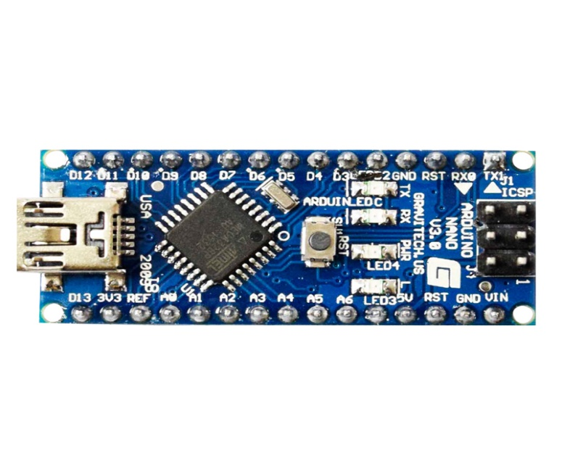

Arduino is an open-source platform used for building electronics projects. Arduino consists of both a physical programmable circuit card (often mentioned as a microcontroller) and a bit of software, or IDE (Integrated Development Environment) that runs on your computer, wont to write and upload code to the physical board.

The Arduino platform has become quite fashionable people just starting out with electronics, and permanently reason. Unlike most previous programmable circuit boards, the Arduino doesn't need a separate piece of hardware (called a programmer) so as to load new code onto the board -- you'll simply use a USB cable. Additionally, the Arduino IDE uses a simplified version of C++, making it easier to find out to program. Finally, Arduino provides a typical form factor that breaks out the functions of the micro-controller into a more accessible package

Arduino boards are ready to read inputs - light on a sensor, a finger on a button, or a Twitter message - and switch it into an output - activating a motor, turning on an LED, publishing something online. you'll tell your board what to try to to by sending a group of instructions to the microcontroller on the board. to try to to so you employ the Arduino programing language (based on Wiring), and therefore the Arduino Software (IDE), supported Processing.

Over the years Arduino has been the brain of thousands of projects, from everyday objects to complex scientific instruments. A worldwide community of makers - students, hobbyists, artists, programmers, and professionals - has gathered around this open-source platform, their contributions have added up to a fantastic amount of accessible knowledge which will be of great help to novices and experts alike.

Arduino was born at the Ivrea Interaction Design Institute as a simple tool for fast prototyping, aimed toward students without a background in electronics and programming. As soon because it reached a wider community, the Arduino board started changing to adapt to new needs and challenges, differentiating its offer from simple 8-bit boards to products for IoT applications, wearable, 3D printing, and embedded environments. All Arduino boards are completely open-source, empowering users to create them independently and eventually adapt them to their particular needs. The software, too, is open-source, and it's growing through the contributions of users worldwide.

* **Jumped wires:**

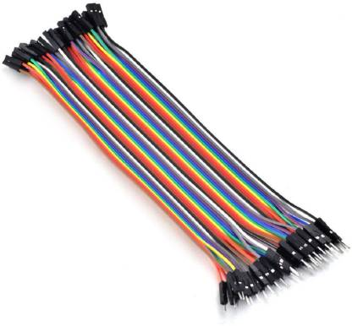

A jump wire (also known as jumper wire, or jumper) is an electrical wire, or group of them in a cable, with a connector or pin at each end (or sometimes without them – simply "tinned"), which is normally used to interconnect the components of a breadboard or other prototype or test circuit, internally or with other equipment or components, without soldering.

Individual jump wires are fitted by inserting their "end connectors" into the slots provided in a breadboard, the header connector of a circuit board, or a piece of test equipment.

**Working:**

A door handle sanitizer for disinfecting a door handle comprising: a source of liquid or gaseous disinfectant; a nozzle fluidly connected to the source configured to convey liquid or gaseous disinfectant from the source to the nozzle and for dispensing the liquid or gaseous disinfectant onto the handle; and an impact circuit for causing the liquid or gaseous disinfectant to be conveyed to the handle in intervals, wherein the intervals are aware of an external condition and therefore the negative feedback circuit if freed from any manual activation.

An apparatus proximate the handle of a door for dispensing germicide onto the handle and into the atmosphere surrounding the handle comprising: a pressurized source of germicide having a normally closed, force actuated valve; a valve actuating means for exerting a force on the valve sufficient to actuate the valve and release the germicide, the valve actuating means comprising: a nozzle fluidly connected to the valve for transporting the germicide from the valve into the atmosphere surrounding the handle; a mechanically driven arm or assembly connected to the valve, the nozzle, or both, operable to supply the force on the valve; and an impact circuit for activating the valve actuating means in intervals, wherein the intervals are aware of an external condition.

A method for sanitizing a door handle of a door comprising the steps of: mounting a dispenser unit proximate the door handle; and spraying a germicide in an atomized mist or liquid form from the dispenser onto the door handle in response to an occasion freed from any manual activation.

**Circuit diagram:**

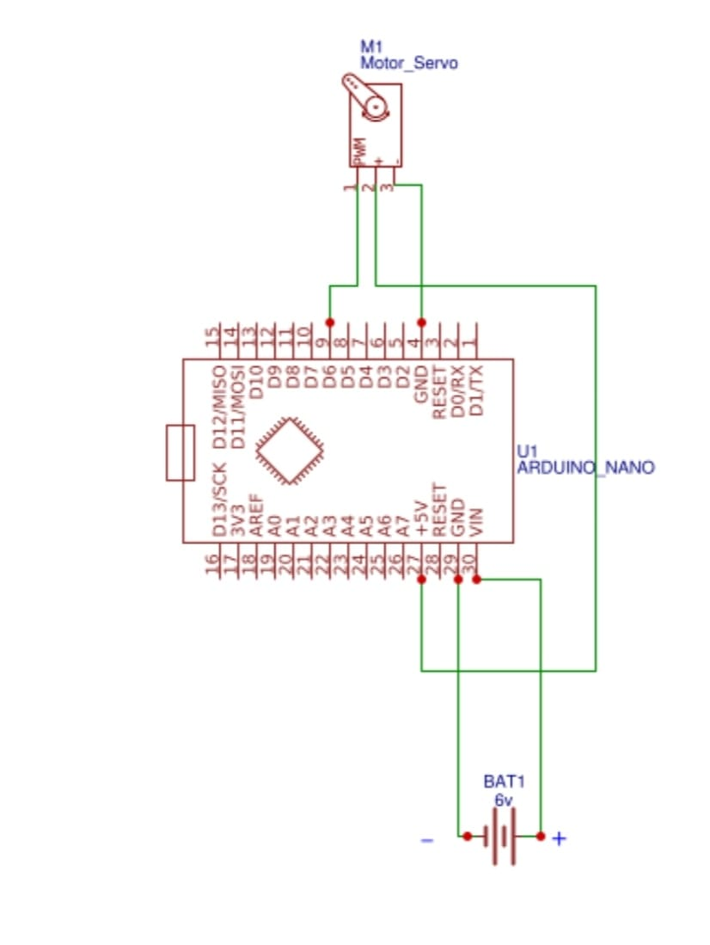

**Program:**

#include”lowpowerr.h”

#include<servo.h>

Servo myservo; //create servo object to control a servo

Int sleepcounter;

Void setup()

{

Myservo.attach(9); //attaches the servo on pin 9 to the servo object

}

Void loop()

{

//0.5hours = 30min*60sec = 1800sec

//1800s/8s =255

For(sleepcounter = 255; sleepcounter>0; sleepcounter--)

{

Lowpower.powerdown(SLEEP_8S,ADC_OFF,BOD_OFF);

}

myservo.write(0); //sets the servo portion according to

delay(1000); //waits for the servo to get there

myservo.write(60); //sets the servo position according to the scaled value

delay(1000);

}

**Advantages:**

* Activated by hand movement under the system. No need to touch anything.
* Gives opportunity not to sanitise handle if you do not wish to. (Allergy)
* Sprays out horizontally to the side which allows different types of handle to be sprayed without the need to change existing door handles.
* Can spray both handle and hands if required.
* Very fine spray, low usage of sanitizer fluid.
* Uses Standard sanitising fluids.
* Low cost and simple to install.

**Disadvanges:**

* It consumes more battery life.
* It’s not operated by current.

**Conclusion:**

The reported project could also be implemented in those areas where there's an enormous crowd and chances of infection are quite. Therefore, it are often utilized in educational institutions, houses, hospitals, and offices, etc. to prevent the spread of bacteria and virus. This product is different from the available products within the market because it is predicated on sensing and rotating method i.e. when the IR sensor senses the hand, the servo rotates and pulls the handle of sanitizer towards it instead of earlier reported project. it pushes the spring downwards.

Through this project, an individual can find out how IR sensors, servo motors work if they need to form it at their home and this is often quite cost-effective. The prototype of the reported product is when an infected person touches the door, then the virus gets attached to the door handle. At that point , this product will help to sanitize the door handle

At present, the planet is facing a difficult time of corona virus pandemic because there's no vaccine to stop till date. Hence, every positive step taken during this direction is extremely important. within the direction of the research field to seek out out the precautions , we've demonstrated an automatic door handle sanitizer supported Arduino Nano, IR sensor, and servo motor to sanitize the handle or knob of the door that's employed by many of us.

As a result of this, the handle or knob of the door can be sanitized automatically whenever the person touches it. The reported project would be a very helpful project for India as well as different countries to protect their families, friends, Citizens to stop the spread of the virus through door gates. Owing to the extensive use of the door handle by users at public places, there is a higher probability of transmission of COVID-19 virus. Therefore, the reported Project/System may help to reduce the risk of spreading the COVID-19 virus.

**Reference:**

* World Health Organization. Naming the coronavirus disease (COVID-19) and the virus that causes it. ed, 2020.
* L. Morawska, J. W. Tang, W. Bahnfleth, P. M. Bluyssen, A. Boerstra, G. Buonanno, et al. How can airborne transmission of COVID-19 indoors be minimised?. Environment international, vol. 142, p. 105832, 2020. [https://doi.org/10.1016/j. envint.2020.105832](https://doi.org/10.1016/j.%20envint.2020.105832)
* M. Alzyood, D. Jackson, H. Aveyard, and J. Brooke. COVID-19 reinforces the importance of hand washing. Journal of Clinical Nursing, 2020. https://doi. org/10.1111/jocn.15313
* M. Alzyood, D. Jackson, J. Brooke, and H. Aveyard. An integrative review exploring the perceptions of patients and healthcare professionals towards patient involvement in promoting hand hygiene compliance in the hospital setting. Journal of clinical nursing, vol. 27, pp. 1329-1345, 2018. <https://doi.org/10.1111/jocn.14305>
* B. Allegranzi, L. Conway, E. Larson, and D. Pittet. Status of the implementation of the World Health Organization multimodal hand hygiene strategy in United States of America health care facilities. American journal of Infection Control, vol. 42, pp. 224-230, 2014. https://doi.org/10.1016/j. ajic.2013.11.015 [6] D. S. C. Lam, R. L. M. Wong, K. H. W